

**Project Report**

**SL-3003 Web.Engineering**

**Project Title**

**Student Portal**

**Group Members**

**Ahmed Hamza (20k-1676)**

**Zain ul Abdin (20k-1672)**

**Siddique Akber (20k-0196)**

**Table of contents**

**Introduction: 3**

**1. Login Screens 4**

**2. Features 6**

Admin 6

Student 7

Teacher 7

**3. Language 8**

**5. DataBase 8**

**6. Environment To Set 9**

# **Introduction:**

Student portal is a website that allows students to view their marks, register themselves in a course and view attendance. It allows teachers to upload marks and mark attendance of students and also allows admin to add student, add teacher, delete student, delete teacher, add course, update student , update teacher ,view history of student and view history for teacher.

This project is the Student Portal which is managing the teachers and students by the Admin . Admin can be multiple Users which are managing the Data by their unique Ids and passwords .

# 

# **Login Screens**

This is main page

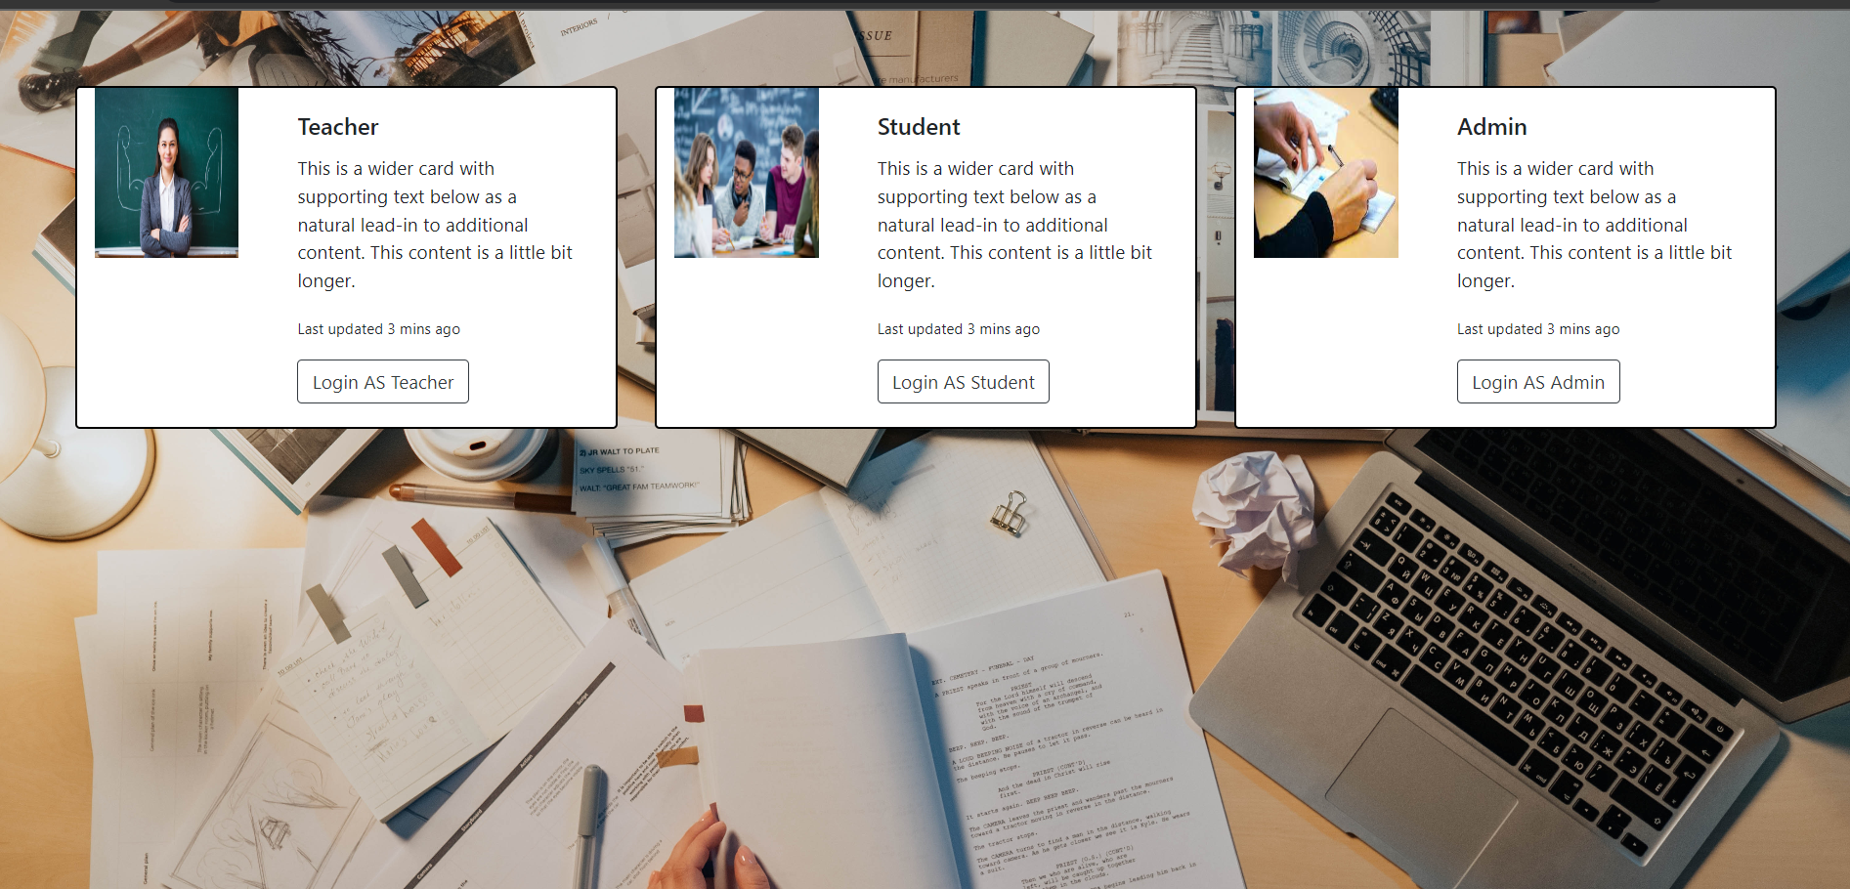

**Admin Login**

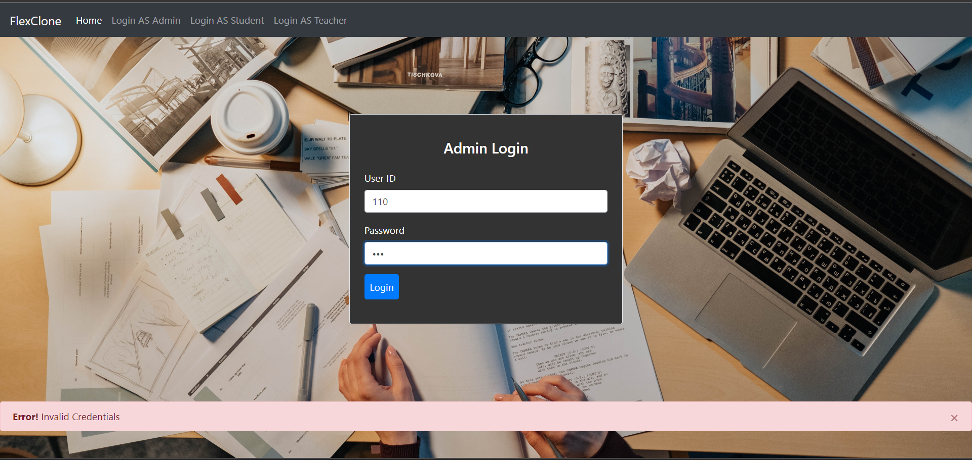

**Student Login**

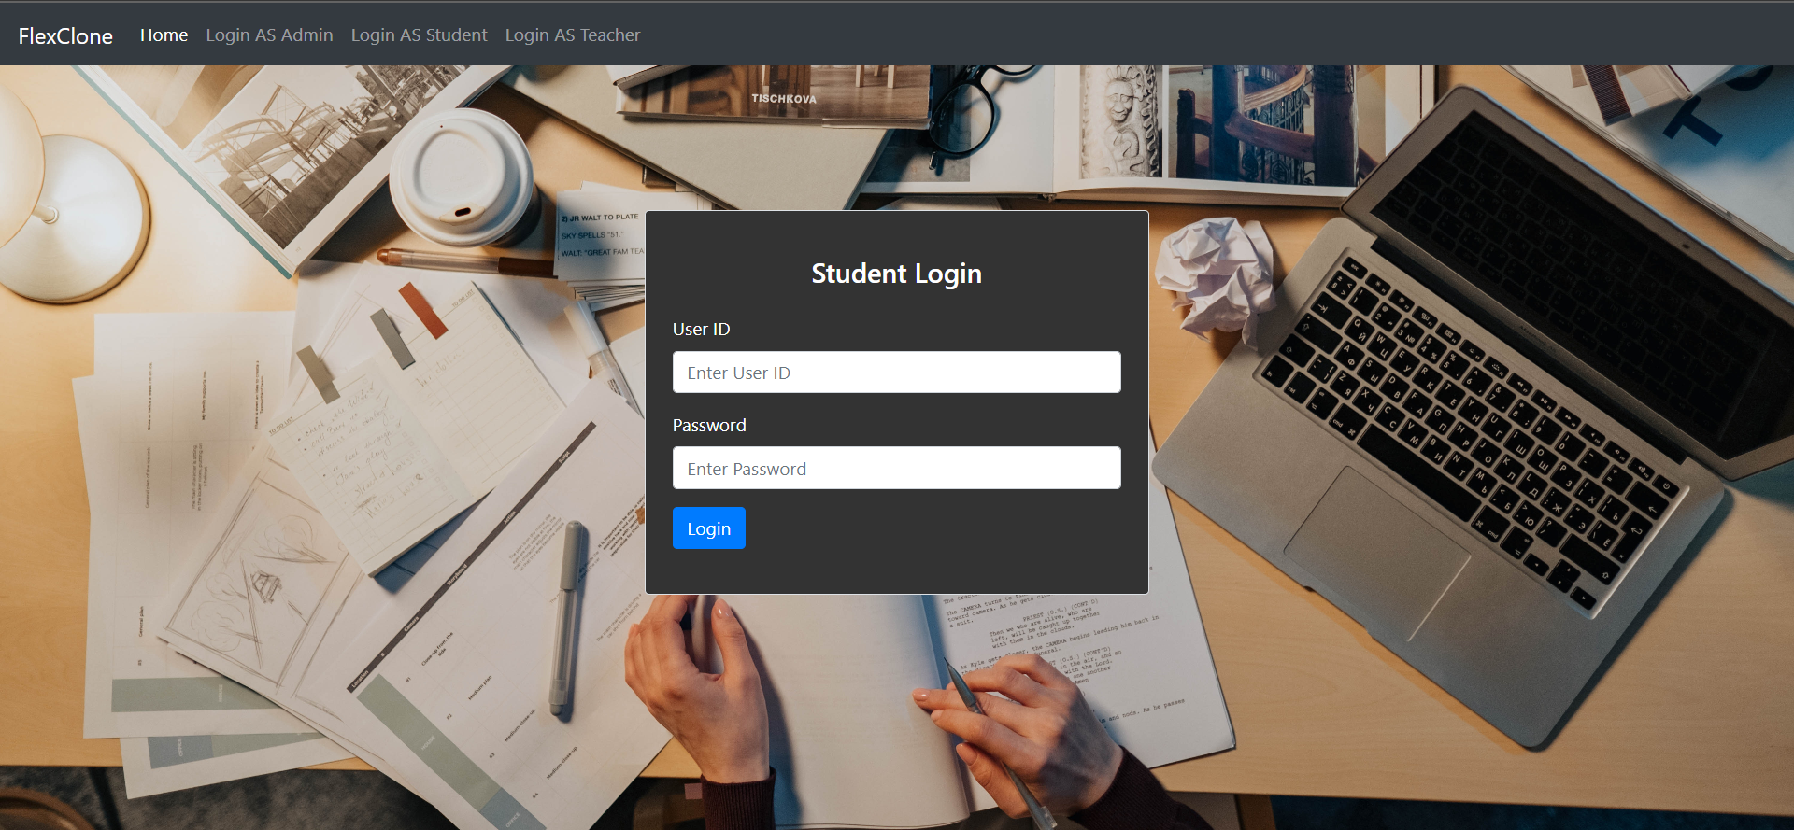

**Teacher Login**

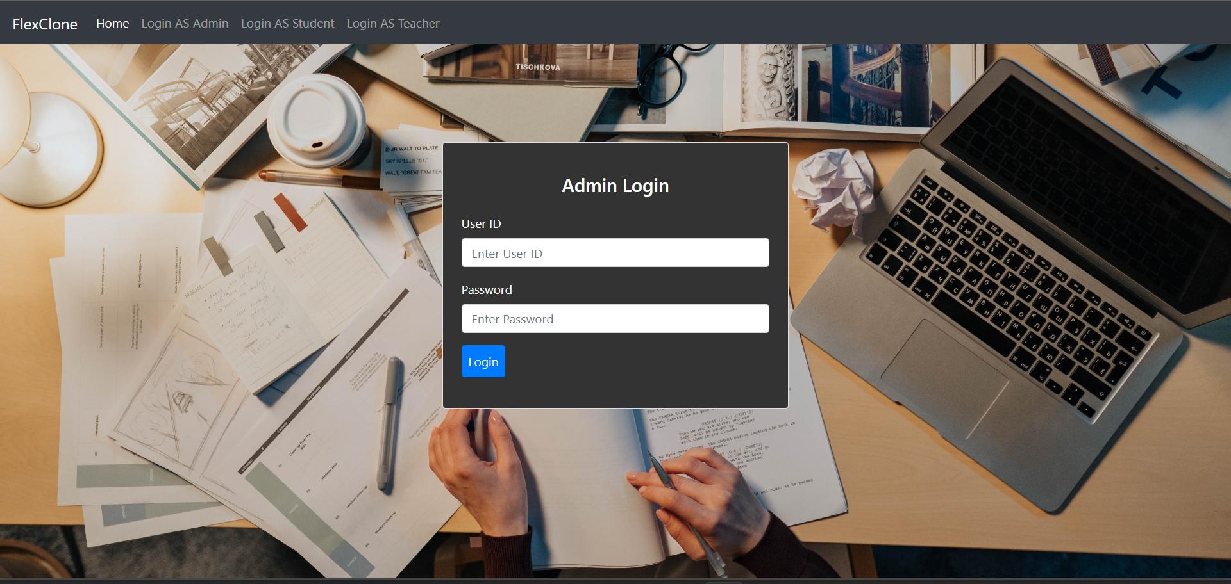

# **Features**

One come feature for all the screen is logout from

User (Teacher , Student Or Admin)

## **Admin**

Following functions are used in the Admin Panel .

* Add Student
* Add Teacher
* Add Course
* Delete Student
* Delete Teacher
* Update Teacher Data
* Update Student Data
* Assign Course to Teacher
* Deleted Student History
* Deleted Teacher HIstory

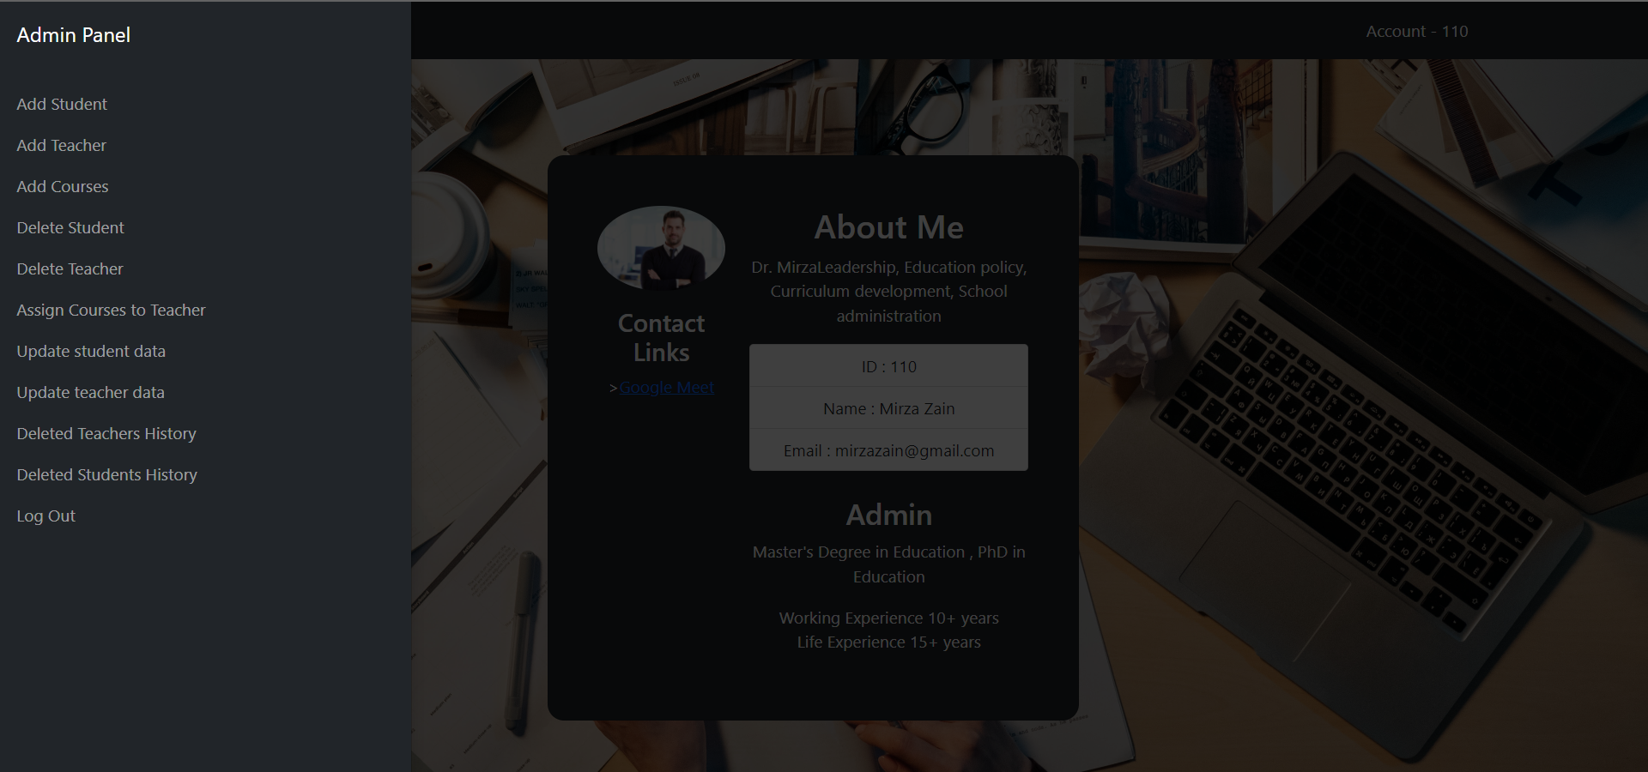

## **Student**

* Register course
* View marks
* View Attendances

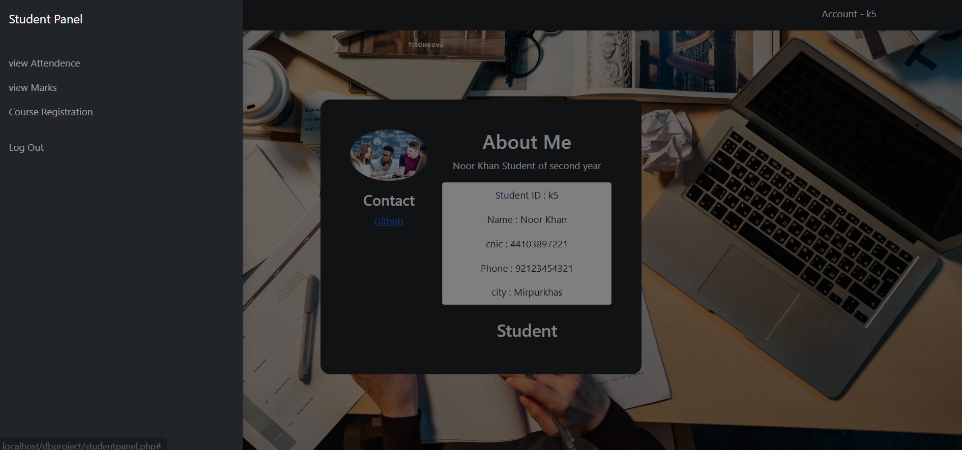

## **Teacher**

* Upload Marks
* Upload Attendances

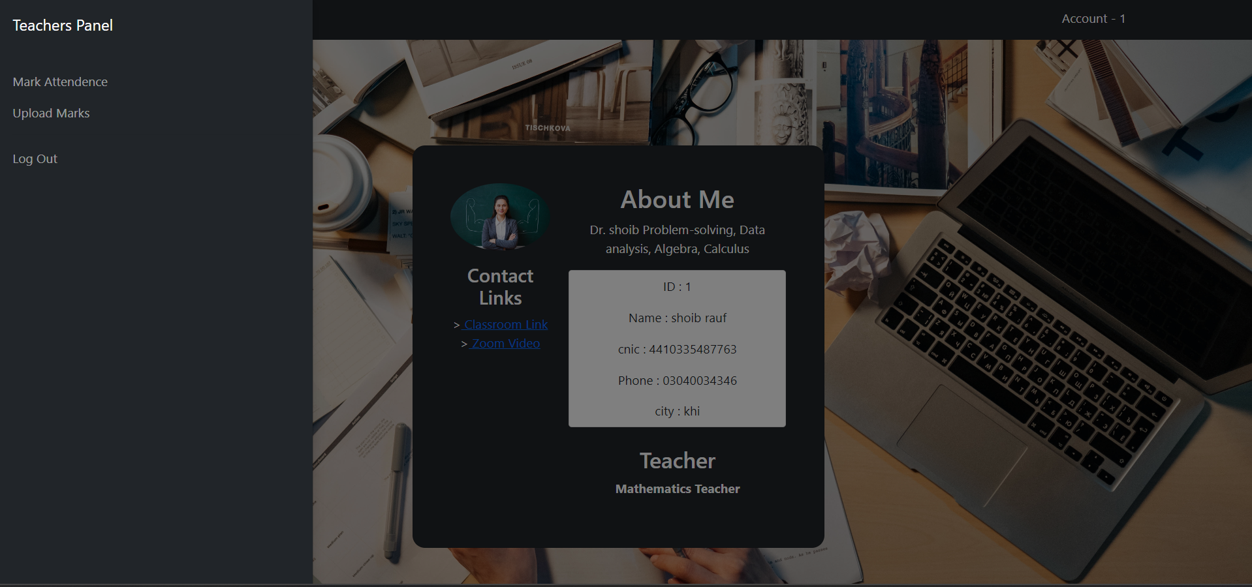

# **Language**

* **Using :**

Html

Css

Php

JavaScript

* **Framework:**

Bootstrap 5

1. **Tool**

* **Server :** Xampp
* **Operating System :** Windows 11
* **Compilar :** Vs Code
* **DataBaseName :** Mydb
* **DBMS :** PhpMyAdmin

# **DataBase**

This is the view of Database .



# **Environment To Set**

1. Use (Vs Code) For coding
2. Xampp Server for Localhost
3. Supported hardware which can run these softwares

# 